# CS 255 System Design Document Template

## UML Diagrams

### UML Use Case Diagram

### UML Activity Diagrams

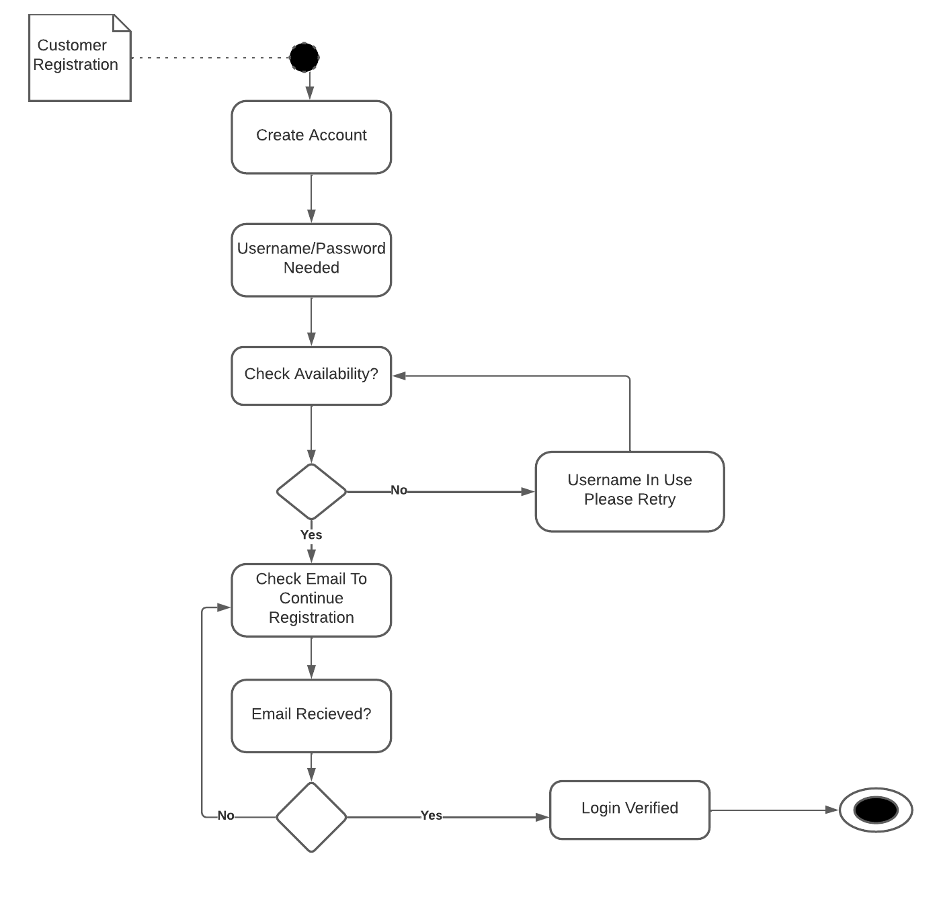

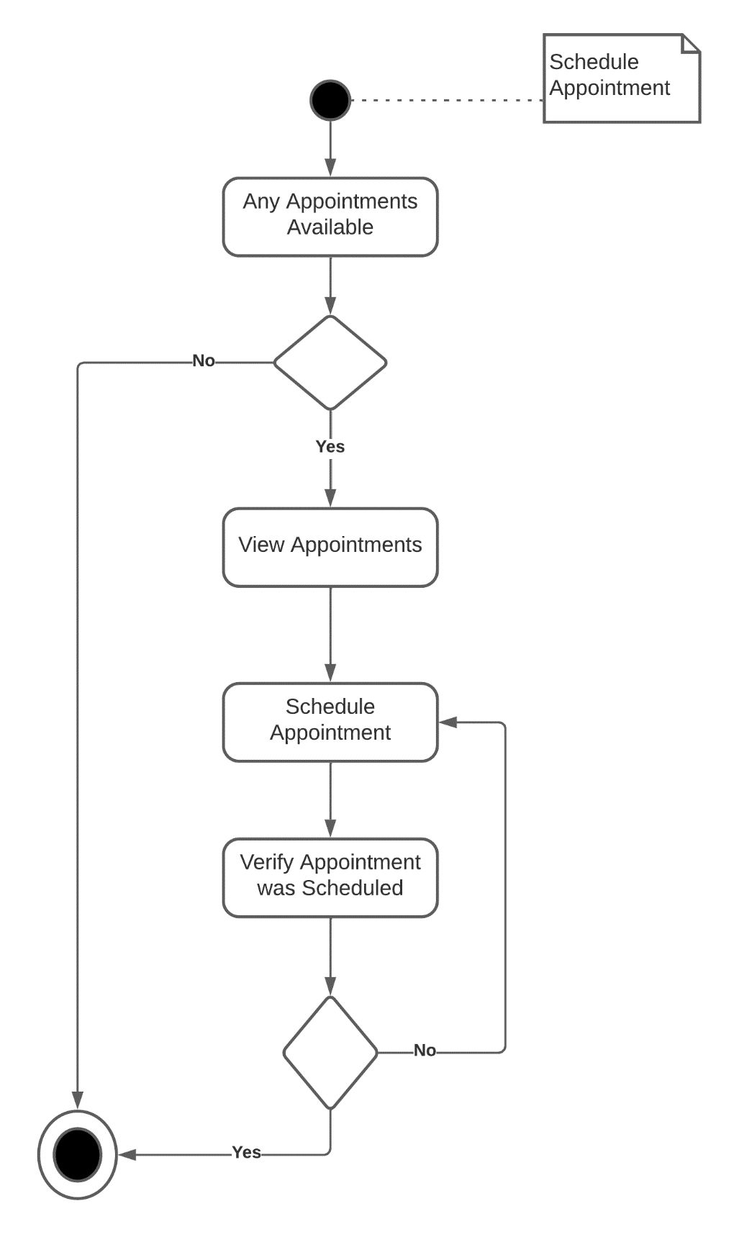

### UML Sequence Diagram

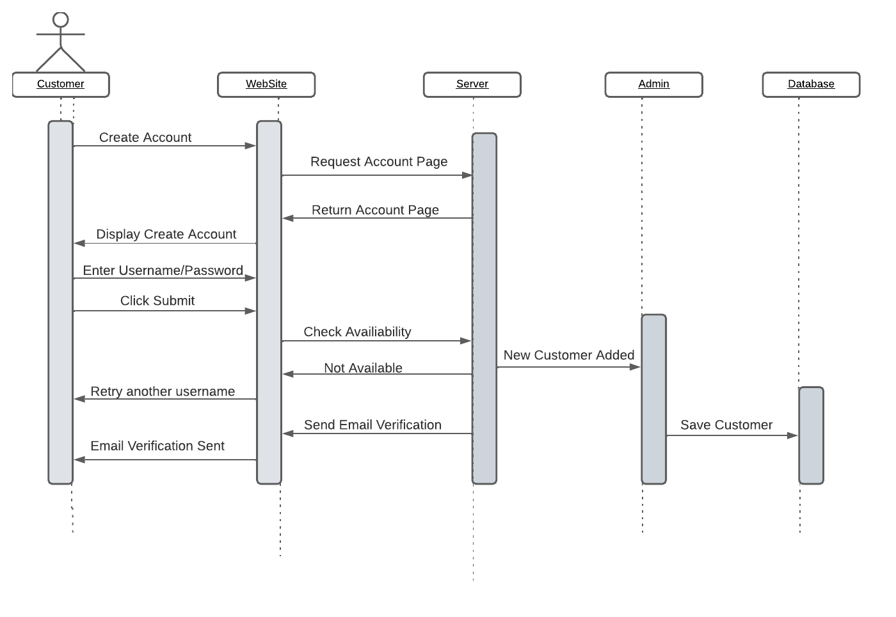

### UML Class Diagram

## Technical Requirements

*The system had a couple technical requirements. First, we developed a system for the web using cloud computing. We also made mobile version for the owner of DriverPass to access in necessary data needed on the go. Since there will be multiple users on the system storing valuable information is key. We will need to add a cloud-based or physical data center to keep all this information stored. All data that users, employees, and the owner would like to share, or download must be encrypted this will ensure the security and data integrity are good to go. By using the cloud platform, you will be able to update all necessary information faster. And since the Owner, IT Officer, Customer, and Secretary all do different things on the system. We implemented a role-base access control to limit access to restricted areas.*